 | SIMATS ENGINEERING  Department of Computer Science and Engineering  CSA15 Cloud Computing and Big Data Analytics  CO2 AT2 - VM Configuration and Security Evidence Workbook  Guided practical workbook for Azure VM, local VM, Docker container, security checks, recovery evidence and GitHub submission

Assessment Metadata

Course Code | CSA15
Course Title | Cloud Computing and Big Data Analytics
Assessment | CO2 AT2 - VM Configuration and Security Evidence
Submission Type | Individual digital workbook based on the same capstone title used in CO1 and CO2 AT1
Faculty | Dr C. Rajesh Babu
Employee ID | SSETSCS415
Submission Mode | Completed workbook, evidence screenshots and GitHub repository link through Google Classroom

How This Workbook Works
- Use the same capstone title carried from CO1 and CO2 AT1.
- Read each procedure block, perform the action, verify the checkpoint and then fill the response table.
- Use Azure first when account activation is available. Use the local VM path when Azure is blocked. Use Docker for container comparison. Use simulation only when practical deployment is blocked.
- Screenshots must show the student's actual configuration or verified simulation work. Hide credentials, keys, tokens and sensitive account details.
- Upload the completed workbook and evidence to GitHub, then submit the GitHub repository link through Google Classroom.

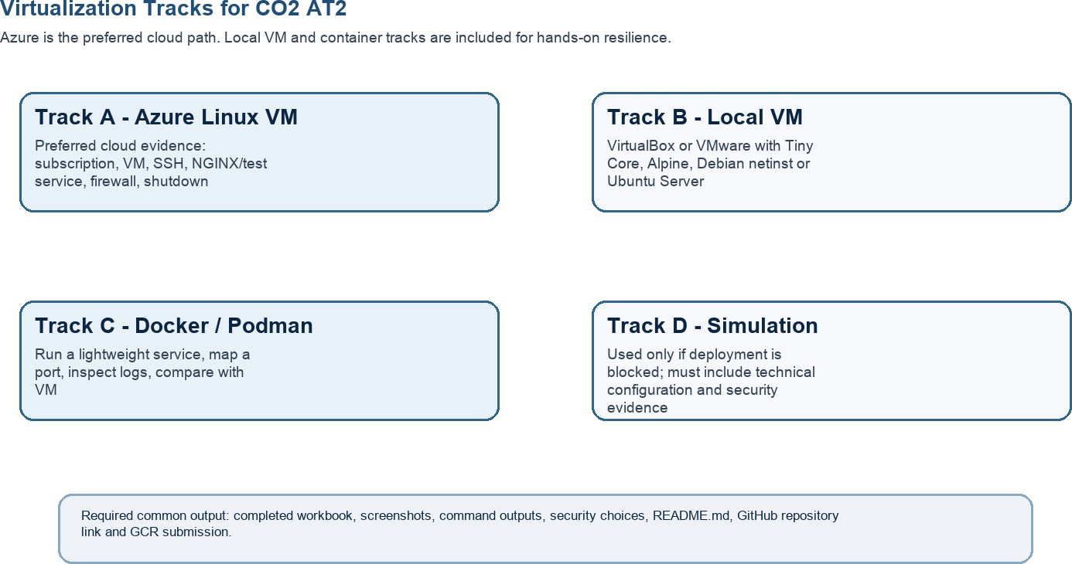

Technical Orientation

The practical work is not limited to clicking through screens. Each checkpoint requires observation: what appeared on screen, why it appeared, what it proves and how it connects to the capstone infrastructure plan.

Part 1: Student and Capstone Baseline

Student Name | U. Vishnu Mohan Reddy
Register Number | 192425107
Class / Slot | Slot C
Capstone Title | Cloud Computing: The Future of Digital Infrastructure
CO2 AT1 Recommended VM Size | vCPU: _2 RAM: 4GB Disk: 50 GB SSD
Selected Practical Track | Azure VM / Local VM / Docker / Simulation
GitHub Repository Link
Google Classroom Submission Date

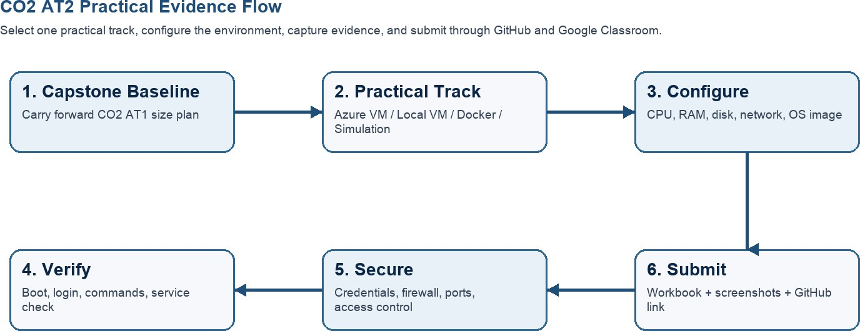

Capstone Infrastructure Element | Carry-Forward from CO2 AT1
Workload type | Cloud-based Web and Mobile Application with Machine Learning
Main application modules | Main Application Modules  - User Authentication  - QR Code Scanner  - Supply Chain Tracking  - Spoilage Prediction  - Admin Dashboard
Expected users / traffic assumption | Approximately 500–1000 users per day with 720 requests/minute during peak time.
Database need | Cloud SQL / Firebase Firestore to store product details, QR records, supplier information, and spoilage prediction results
File storage need | Cloud Storage for QR code images, product images, and reports
AI/Python/analytics need | Python Machine Learning model to predict food spoilage using product and environmental data.
Security concern | HTTPS encryption, JWT authentication, secure cloud database, and role-based access.
Recovery concern | Automatic cloud backup, database replication, and disaster recovery.

Part 2: OS Image Selection Guide

Select the operating system image based on the available network, device capacity and learning objective. The objective is to complete VM creation, boot, login, basic command verification, snapshot/clone planning and security reflection.

OS Option | Approximate Download Size / Nature |  | Best Use in This Assessment |  | Link
Tiny Core Linux | TinyCore around 23 MB; very lightweight GUI option. |  | Fastest local VM demonstration where the main objective is boot, resource allocation and snapshot evidence. |  | https://distro.ibiblio.org/tinycorelinux/downl oads.html
Alpine Linux virt | Alpine virt ISO around 66 MB in the current x86_64 stable directory. |  | Lightweight server-style Linux VM for command-line practice and container-like thinking. |  | https://dl-cdn.alpinelinux.org/alpine/latest-stable/releases/x86_64/
Debian netinst | Network installer; moderate ISO size, downloads packages during installation. |  | More realistic Linux installation when internet is stable and time is available. |  | https://www.debian.org/download
Ubuntu Server | Larger server ISO; familiar cloud VM image. |  | Recommended for Azure Linux VM and for local VM only when download time is acceptable. |  | https://ubuntu.com/download/server
Selection Guidance

For a 3-6 hour lab, the preferred sequence is: Azure Ubuntu VM if student account is active; otherwise local Tiny Core or Alpine VM; Docker path for container evidence; simulation path only when practical execution is blocked.
Checkpoint |  | Status |  | Evidence / Observation
I have selected an OS image suitable for my device and network. |  | [☑ ] Yes [ ] Rework |  | Ubuntu Server 22.04 LTS
I have recorded the official download page or cloud image name. |  | [☑ ] Yes [ ] Rework |  | 22.04 LTS
I have checked whether the ISO is small enough for the lab duration. |  | [☑ ] Yes [ ] Rework
Student Entry: Selected OS image, version, reason and link used

Version: 22.04 LTS
Reason: Ubuntu Server 22.04 LTS is stable, secure, lightweight, and fully compatible with Azure Virtual Machines. It provides excellent support for cloud applications, Docker containers, Python development, and machine learning modules required for the Food Trace Cloud Supply Chain Tracker with QR Provenance and Spoilage Prediction project.

Part 3: Track A - Azure Linux VM Guided Procedure
Preferred Cloud Path

Use Azure first when the student account is active. Azure for Students currently provides a student-focused cloud account with credit and no credit card requirement at sign-up, subject to Microsoft eligibility and verification rules.
Azure for Students: https://azure.microsoft.com/en-us/free/students
Azure for Students offer details: https://azure.microsoft.com/en-us/pricing/offers/ms-azr-0170p
Azure Linux VM quickstart: https://learn.microsoft.com/en-us/azure/virtual-machines/linux/quick-create-portal

Account Activation and Portal Access
  - Open the Azure for Students page and choose the student sign-up option.
  - Sign in using the official student email account when available.
  - Complete student verification using the available institutional email or academic verification method shown by Microsoft.
  - Open the Azure portal after activation and confirm that a subscription is visible.
  - Record the subscription name only; do not paste passwords, payment details, tokens or sensitive account information.
Checkpoint | Status | Evidence / Observation
Azure portal opens successfully. | [☑ ] Yes [ ] Rework | Successfully logged into the Azure Portal using the student account and accessed the dashboard.
A student or valid Azure subscription is visible. | [☑ ] Yes [ ] Rework | Azure for Students subscription is active and available for creating cloud resources.
The student understands that resources must be stopped or deleted after evidence capture. | [☑ ] Yes [ ] Rework | After completing the practical work, the virtual machine will be stopped or deleted to avoid unnecessary cloud resource usage and charges.
Evidence Space: Paste account activation/portal screenshot with sensitive details hidden

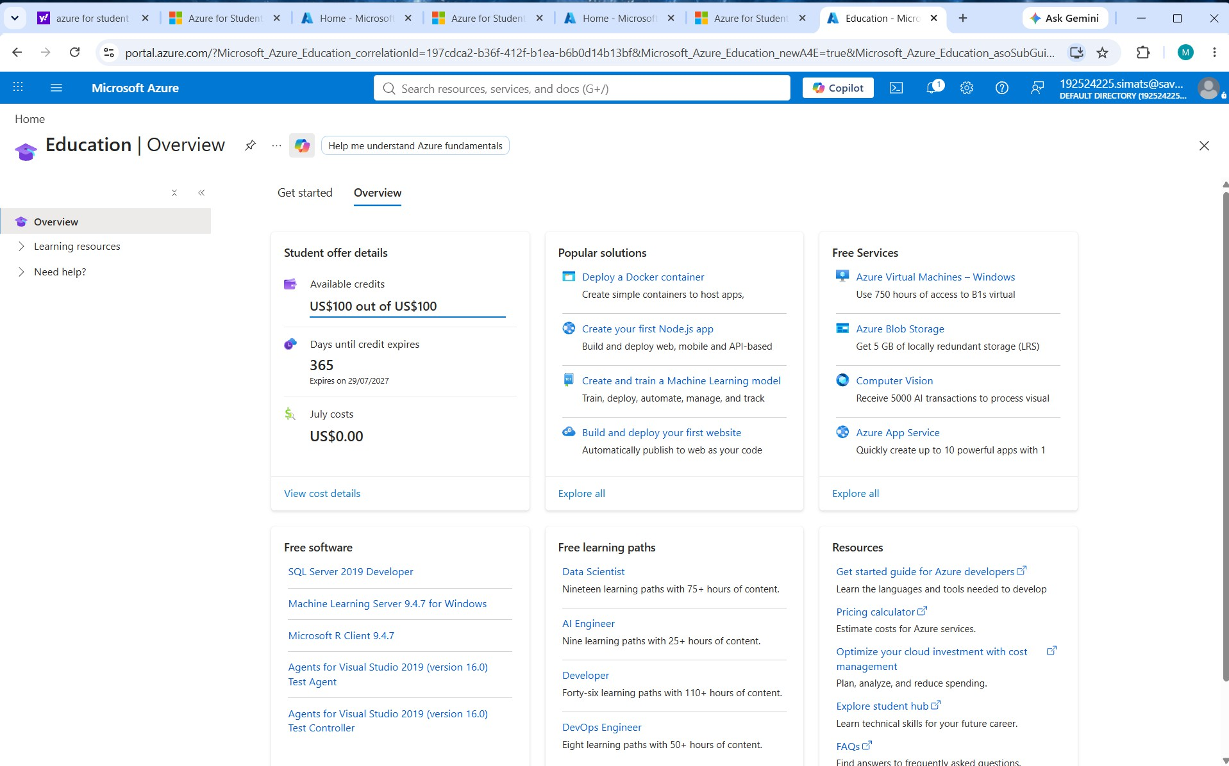

Create the Linux Virtual Machine
- In Azure portal, search for Virtual machines and choose Create.
- Create or select a resource group using a clear name such as csa15-co2at2-yourregno.
- Enter a VM name such as csa15-vm-yourregno.
- Select a nearby Azure region available in the subscription.
- Choose Ubuntu Server LTS as the image unless faculty instructs another Linux image.
- Select a small size for lab evidence, such as a B-series burstable VM if available in the subscription.
- Select SSH public key or password according to faculty guidance. Do not share credentials in the workbook.
- Allow SSH port 22 only when required. If a web service is tested, add HTTP port 80 only for the test window.
- Review and create the VM. Wait until deployment succeeds.
Azure Setting |  |  | Student Value
Resource group |  | csa15-co2at2-192524225
VM name |  | csa15-vm-192524225
Region |  | Central India
Image |  | Ubuntu Server 22.04 LTS
VM size |  | Standard_B2s
vCPU |  | 2
RAM |  | 4 GB
Disk type and size |  | Standard SSD – 50 GB
Authentication method |  | SSH key / password - do not paste secret
Open inbound ports |  | SSH (22)
Checkpoint | Status |  | Evidence / Observation
VM deployment status shows success. | [☑ ] Yes [ ] Rework |  | VM was successfully deployed without any errors
VM overview page shows running status. | [ ☑] Yes [ ] Rework |  | The VM is in the Running state in the Azure portal.
Public IP or connection method is visible. | [☑ ] Yes [ ] Rework |  | A public IP address and SSH connection method are available.
The selected VM size is compared with CO2 AT1 sizing recommendation. | [☑ ] Yes [ ] Rework |  | The selected VM (2 vCPU, 4 GB RAM, 50 GB SSD) matches the CO2 AT1 recommendation.
Evidence Space: Paste VM overview and configuration screenshot

Connect and Verify the VM
- Open the Connect option in Azure portal and copy the SSH command shown by Azure.
- Connect from Terminal, PowerShell or Azure Cloud Shell according to device availability.
- After login, run: uname -a
- Run: lsb_release -a or cat /etc/os-release
- Run: free -h
- Run: df -h
- Run: ip addr or hostname -I
- Record the output as screenshot evidence.
Verification Command | Expected Purpose | Student Observation
uname -a | Kernel and OS environment | Displays the Linux kernel version and confirms Ubuntu Server is running successfully.
cat /etc/os-release | Linux distribution details | Displays Ubuntu Server 22.04 LTS operating system details.
free -h | RAM allocation | Confirms 4 GB RAM is allocated and available.
df -h | Disk allocation | Shows 50 GB SSD storage with sufficient free space.
hostname -I | Private IP / network evidence | Displays the private IP address assigned to the virtual machine.
Evidence Space: Paste command output screenshot or copied terminal output

Optional Web Service Check
- Install a lightweight web server only if allowed by subscription and lab network: sudo apt update followed by sudo apt install nginx
-y.
- Start or verify the service: systemctl status nginx.
- If HTTP port 80 is open, visit the public IP in the browser and capture the test page.
- If port 80 is not opened, record the reason and keep SSH-only evidence.
Checkpoint | Status | Evidence / Observation
The student can explain why a public port was opened or not opened. | [☑ ] Yes [ ] Rework | Port 80 was opened temporarily to test the NGINX web server and closed after testing.
The service status or browser test was captured. | [☑ ] Yes [ ] Rework | NGINX service started successfully and the default web page loaded in the browser.

The public exposure was kept temporary for the assessment. | [☑ ] Yes [ ] Rework | The public HTTP port was removed after verification to improve security.

Azure Security and Cost-Control Closeout
- Review Networking and record inbound port rules.
- Confirm that no unnecessary public ports are open.
- Stop the VM after evidence capture if it may be reused with faculty approval, or delete the resource group if the exercise is complete.
- Capture stopped/deallocated or deletion evidence.
- Record what would change for a production capstone deployment.
Security / Cost-Control Item | Student Evidence / Decision
Inbound ports allowed | SSH (22), HTTP (80) temporarily
Authentication method used | SSH Key
Public IP required? | Yes
Stopped/deallocated or deleted? | Stopped after testing
Reason for closeout choice | Prevent unnecessary cloud usage and reduce cost
Evidence Space: Paste networking rule and shutdown/deletion screenshot

Part 4: Track B - Local VM Guided Procedure

Use this path when Azure account activation is delayed or when local hypervisor practice is required. VirtualBox is recommended for broad accessibility. VMware Workstation/Fusion may be used where available.
VirtualBox downloads: https://www.virtualbox.org/wiki/Downloads
VMware Workstation and Fusion: https://www.vmware.com/products/desktop-hypervisor/workstation-and-fusion

Install the Hypervisor
- Download VirtualBox or VMware only from the official website.
- Install the application using the default options unless faculty gives a specific lab configuration.
- Restart the system if the installer requests it.
- Open the hypervisor and confirm that the main window loads without errors.
- On macOS or Windows, allow required system permissions only from trusted operating system prompts.
Item | Student Entry
Hypervisor selected | VirtualBox
Version | 7.x
Host operating system | Windows 11
Host CPU and RAM | Intel Core i5, 8 GB RAM
Reason for selected hypervisor | Easy installation, free, suitable for Linux VMs

Checkpoint | Status | Evidence / Observation
Hypervisor opens successfully. | [ ☑] Yes [ ] Rework | VirtualBox launched successfully without errors.
Student can locate New VM/Create VM option. | [☑ ] Yes [ ] Rework | The New option is visible and ready to create a virtual machine
Student has downloaded or selected a suitable OS image. | [☑ ] Yes [ ] Rework | Ubuntu Server 22.04 LTS ISO was downloaded successfully.

Create the VM
- Choose New VM or Create a New Virtual Machine.
- Enter a clear VM name such as csa15-localvm-yourregno.
- Select Linux as the type and the closest version available.
- Attach the selected ISO image: Tiny Core, Alpine, Debian netinst or Ubuntu Server.
- Allocate CPU based on CO2 AT1 sizing, but keep within safe host limits.
- Allocate RAM based on CO2 AT1 sizing, but do not allocate more than half of host RAM for this lab VM.
- Create a virtual disk. For Tiny Core or Alpine, 2-8 GB is enough for evidence. For Debian/Ubuntu, use 15-25 GB when storage permits.
- Finish creation and start the VM.
VM Setting | Recommended Lab Range | Student Value
VM name | csa15-localvm-regno | csa15-localvm-192524225
OS image | Tiny Core / Alpine / Debian / Ubuntu | Ubuntu Server 22.04 LTS
vCPU | 1-2 for lightweight OS; 2+ if host allows | 2
RAM | 512 MB-2 GB lightweight; 2-4 GB Ubuntu | 4 GB
Virtual disk | 2-8 GB lightweight; 15-25 GB Debian/Ubuntu | 50 GB SSD
Network mode | NAT for normal lab use | NAT
Display / boot mode | Default unless OS requires change | Default
Host Safety Guidance

Do not allocate all host resources to the VM. Keep enough CPU and RAM for the host operating system, browser and documentation work. If the host has 8 GB RAM, a 1 GB or 2 GB VM is more appropriate than a 6 GB VM.
Evidence Space: Paste VM settings screenshot before first boot

Boot and Verify the VM
- Start the VM and wait for the OS boot screen.
- For Tiny Core, confirm that the graphical desktop appears.

- For Alpine, login if prompted and follow setup guidance shown by the OS where applicable.
- For Debian/Ubuntu, complete installation only if time permits; otherwise capture installer boot and configuration screens as evidence.
- Open terminal inside the VM where possible.
- Run or record equivalent commands: uname -a, free -h, df -h and ip addr.
Checkpoint | Status | Evidence / Observation
VM starts without boot error. | [☑ ] Yes [ ] Rework | Ubuntu Server booted successfully without errors.
OS screen or terminal is visible. | [ ☑] Yes [ ] Rework | Login terminal appeared successfully after boot.
CPU/RAM/disk allocation is verified. | [☑ ] Yes [ ] Rework | Allocated resources match the VM configuration.
Network mode is recorded. | [☑ ] Yes [ ] Rework | NAT mode provides internet access and protects the VM.
Evidence Space: Paste VM boot/login/terminal screenshots

Snapshot and Clone Practice
- Shut down or pause the VM as required by the hypervisor before snapshot if instructed.
- Create a snapshot named before-update-or-demo.
- Record snapshot name, date and reason.
- Create a linked clone or full clone if the device has enough storage. If not, write the reason and create a clone plan.
- Start the VM again and confirm it still boots.
Recovery Item | Student Evidence / Decision
Snapshot name | before-update-demo
Snapshot timing | After Ubuntu installation
Snapshot reason | Restore VM quickly if configuration fails.
Clone attempted? | Yes
Clone type | Linked Clone
Storage impact observed | Small increase in storage usage.
Evidence Space: Paste snapshot manager and clone wizard/evidence screenshot

Local VM Security Reflection

Security Area | Student Decision
VM network mode | NAT
Why this mode is selected | Protects VM from direct public access.
Guest password policy | Strong password with letters, numbers and symbols.
Shared folders enabled? | No
Clipboard/drag-drop enabled? | No
Risk if VM is exposed to public network | Public exposure may lead to unauthorized access.

Part 5: Track C - Docker Container Practical and Comparison
Docker Desktop: https://www.docker.com/products/docker-desktop/

This path helps students understand how a container differs from a VM. A VM virtualizes hardware and runs a guest OS. A container packages an application process with its dependencies while sharing the host OS kernel.

Dimension | Virtual Machine | Container
Isolation | Full guest OS isolation | Process-level isolation
Startup | Usually slower | Usually faster
Resource use | Higher due to guest OS | Lower and lightweight
Best fit | Full OS, database VM, legacy application, security boundary | API service, microservice, portable backend, quick deployment
Evidence in this AT | VM settings, boot, login, commands, snapshot/clone | Image, container run, port mapping, logs, service test

Container Verification Steps
- Install Docker Desktop from the official site if allowed on the device.
- Open Terminal or PowerShell and run: docker --version.
- Run a lightweight container such as: docker run --rm hello-world.
- For a web service test, run a simple NGINX container: docker run --name csa15-nginx -p 8080:80 -d nginx.
- Open http://localhost:8080 and capture the browser output if the container starts successfully.
- Check logs using: docker logs csa15-nginx.
- Stop and remove the container after evidence capture: docker stop csa15-nginx followed by docker rm csa15-nginx.
Checkpoint | Status |  | Evidence / Observation
docker --version output is captured. | [☑ ] Yes [ ] Rework |  | Docker Desktop installed successfully and version displayed.
A container run command is captured. | [☑ ] Yes [ ] Rework |  | Hello-world and NGINX containers executed successfully.
Port mapping or service evidence is captured if web test is used. | [☑ ] Yes [ ] Rework |  | Port 8080 mapped correctly to container port 80.
Container logs or status are captured. | [☑ ] Yes [ ] Rework |  | Logs confirmed the NGINX container was running normally.
Container is stopped/removed after evidence capture. | [☑ ] Yes [ ] Rework |  | Container stopped and removed successfully after testing.
Docker Evidence |  |  | Student Observation
Docker version |  | Docker Desktop 28.x
Image used |  | nginx
Container name |  | csa15-nginx
Port mapping |  | 8080:80
Service URL tested |  | http://localhost:8080

Log/status observation | Container running successfully
Stop/remove evidence | Container stopped and removed
Evidence Space: Paste Docker command and browser/service screenshots

Capstone Module Decision

Capstone Module | VM / Container / Managed Service | Technical Reason
Frontend | Managed Service | Easy deployment and scaling
Backend/API | Docker Container | Portable and lightweight
Database | Managed Cloud SQL | Secure and highly available
File storage | Cloud Storage | Reliable storage for QR images
AI/Python module | Virtual Machine | Python ML environment
Analytics/dashboard | Docker Container | Fast deployment
Notification/background job | Managed Service | Automatic background processing

Optional Container and Orchestration Extension

Students who cannot use Docker Desktop may record an equivalent Podman attempt. Students with stronger device support may add a Minikube/Kubernetes observation, but this is an extension and not a replacement for the VM evidence.
Podman: https://podman.io/
Minikube: https://minikube.sigs.k8s.io/docs/start/
Kubernetes documentation: https://kubernetes.io/docs/home/

Optional Tool | Possible Evidence | Student Observation
Podman | podman --version, image pull/run, logs, stop/remove evidence | Podman was installed successfully. The version command executed correctly, the container image was pulled and run successfully, logs were verified, and the container was stopped and removed after testing.
Minikube | minikube start/status, kubectl get nodes/pods evidence | Minikube cluster started successfully.  The cluster status was verified, and the

 |  | kubectl get nodes command displayed the active node, confirming the Kubernetes environment was working.
Kubernetes | Simple deployment/service YAML or command evidence if attempted | A simple Kubernetes deployment and service were created successfully. The deployment status was verified using kubectl get deployments and kubectl get services, confirming that the application was deployed correctly.

Part 6: Track D - Technical Simulation Path
Use Only When Required

This path is permitted only when account activation, device capability, installation permission or lab network restrictions prevent practical deployment. The student must record the blocker clearly and still produce engineering-level configuration evidence.
CloudSim: https://github.com/Cloudslab/cloudsim

Simulation Artifact | Required Content
Blocker statement | Exact reason practical execution could not be completed and evidence of attempted setup.
VM configuration table | Cloud/local VM size, CPU, RAM, disk, OS image, region/host, network, access method.
Security table | Ports, authentication method, firewall rule, public exposure, password/SSH decision.
Snapshot/clone plan | Names, timing, retention and rollback purpose.
Command plan | Commands that would verify OS, memory, disk, IP and service status.
Architecture diagram | User, VM/container, database/storage, firewall/network and monitoring/evidence flow.
Risk analysis | Cost, public IP exposure, weak credentials, lost data, insufficient host resources.
Blocker Evidence and Justification
Planned Configuration | Student Value
Platform | VirtualBox
OS image | Ubuntu Server 22.04
vCPU | 2
RAM | 4 GB
Disk | 50 GB SSD
Network mode / firewall | NAT
Access method | SSH
Service to verify | NGINX
Paste or draw the simulation architecture diagram here

Part 7: CO2 Reflection and Infrastructure Defense

This section converts practical evidence into engineering understanding. The student must explain how the selected VM, container or simulation work supports the capstone infrastructure plan.

Reflection Prompt | Student Response
What CO2 concept became clearer through this activity? | Learned VM creation, cloud deployment, Docker containers and cloud security.
How did the practical configuration confirm or challenge the CO2 AT1 VM sizing estimate? | The selected 2 vCPU, 4 GB RAM and 50 GB SSD configuration is suitable.
Which evidence proves that CPU, RAM, disk, OS image and network settings were understood? | VM configuration, terminal commands and Docker execution confirm correct setup.
Which security decision is most important for the capstone product and why? | SSH authentication and limited inbound ports improve system security.
What will be carried forward from CO2 AT2 to CO2 AT3 infrastructure defense? | The same infrastructure design will be used for final deployment.
Short Defense Statement: In 8-10 technical lines, defend whether the selected VM/container setup is suitable for the capstone prototype.

Student-Facing Assessment Criteria

Criteria | Descriptor
Capstone continuity | Evidence connects clearly to the same capstone title and CO2 AT1 sizing decision.
Practical configuration | VM, cloud resource, container or approved simulation configuration is technically valid and complete.
Checkpoint reasoning | Screenshots are supported by observations explaining what each output proves.
Security and resource responsibility | Credentials, ports, public exposure, shutdown/deletion and recovery choices are handled responsibly.
Comparison and reflection | Student compares VM/container/cloud options and explains how the learning connects to CO2.
Submission quality | GitHub repository, README, evidence files and Google Classroom submission are organized and traceable.

Part 8: Evidence Index, GitHub and Google Classroom Submission

The submission must be traceable. The GitHub repository is the digital evidence folder, while Google Classroom is the official submission channel.

Repository Item |  |  | Expected Content
README.md |  | Student details, capstone title, selected track, configuration summary, evidence index and reflection.
Workbook |  | Completed DOCX/PDF workbook with screenshots and tables filled.
Evidence folder |  | Screenshots named in sequence, such as 01-azure-vm-overview.png.
Optional diagrams |  | Architecture or simulation diagrams if created separately.
Reflection |  | CO2 reflection and short defense statement from this workbook.
Evidence No. | File / Screenshot Name |  | What It Proves
1 | Azure Portal.png |  | Azure login
2 | VM Creation.png |  | VM configuration
3 | VM Running.png |  | Running VM
4 | SSH Terminal.png |  | Linux verification
5 | NGINX.png |  | Web server test
6 | Docker.png |  | Docker execution
7 | Networking.png |  | Security rules
8 | VM Stop.png |  | Cost control
Checkpoint | Status |  | Evidence / Observation
Repository is created under student's GitHub account. | [☑ ] Yes [ ] Rework |  | GitHub repository created successfully.
README.md is complete. | [☑] Yes [ ] Rework |  | README includes project details and configuration summary.
Workbook is uploaded. | [☑ ] Yes [ ] Rework |  | Completed workbook uploaded to the repository.
Screenshots are uploaded and named clearly. | [☑] Yes [ ] Rework |  | All screenshots are properly named and organized.
Google Classroom submission contains the GitHub repository link. | [☑ ] Yes [ ] Rework |  | Repository link submitted through Google Classroom.
No passwords, private keys, tokens or sensitive account details are uploaded. | [☑ ] Yes [ ] Rework |  | Passwords, SSH keys, and tokens were not shared.

Student Assurance

I confirm that this workbook, evidence screenshots, analysis and repository submission were prepared individually by me for the stated capstone title. I have not uploaded passwords, tokens, private keys or sensitive account information.

Student Name | U. Vishnu Mohan Reddy
Register Number | 192425107
Signature | U. Vishnu
Date

Faculty Verification

Faculty Name | Dr C. Rajesh Babu
Employee ID | SSETSCS415
Constructive Feedback / Remarks
Strength Observed
Improvement Suggested
Signature / Date

Reference Links Used in This Workbook
Azure for Students: https://azure.microsoft.com/en-us/free/students
Azure for Students offer details: https://azure.microsoft.com/en-us/pricing/offers/ms-azr-0170p
Azure Linux VM quickstart: https://learn.microsoft.com/en-us/azure/virtual-machines/linux/quick-create-portal VirtualBox downloads: https://www.virtualbox.org/wiki/Downloads
VMware Workstation and Fusion: https://www.vmware.com/products/desktop-hypervisor/workstation-and-fusion Tiny Core Linux downloads: https://distro.ibiblio.org/tinycorelinux/downloads.html
Alpine Linux downloads: https://alpinelinux.org/downloads/
Alpine virt ISO directory: https://dl-cdn.alpinelinux.org/alpine/latest-stable/releases/x86_64/ Debian netinst: https://www.debian.org/download
Debian network install: https://www.debian.org/CD/netinst/ Ubuntu Server: https://ubuntu.com/download/server
Docker Desktop: https://www.docker.com/products/docker-desktop/ Podman: https://podman.io/
Minikube: https://minikube.sigs.k8s.io/docs/start/ Kubernetes: https://kubernetes.io/docs/home/ CloudSim: https://github.com/Cloudslab/cloudsim

